13.1.6 Editors - Video Sequence Editor - Header - Select Menu
Select menu 1
All 1
None 1
Inverse 1
Box Select 2
Box Select (Include Handles) 2
Side of Frame 2
Left 2
Right 2
Handle 2
Both 2
Left 2
Right 2
Last operator Select Handles 2
Side 2
Channel 2
Left 2
Right 3
Both sides 3
Linked 3
All 3
Less 3
More 3
Grouped 3
Last operator Select Grouped 3
Type 3
Extend 3
Same Channel 3

Select menu

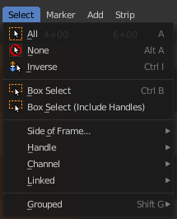
This menu exists in Sequencer view type.

All
Select everything.

None
Select nothing.

Inverse
Invert the current selection.

Box Select
Draw a rectangle to box select strips.
It adds to selection by default. To subtract from selection hold down Shift key.

Box Select (Include Handles)
Draw a rectangle to box select the handles of the strips. A strip has a resize handle at the start and the end of the strip.
It adds to selection by default. To subtract from selection hold down Shift key.

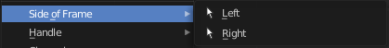
Side of Frame

Left
Select the strips left from the current frame.

Right
Select the strips right from the current frame.

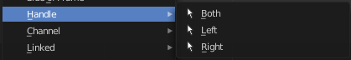
Handle

Both
Select all handles of the selected strips.

Left
Select the left handles of the selected strips.

Right
Select the right handles of the selected strips.

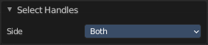
Last operator Select Handles

Side
Which side to select.

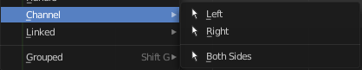
Channel

Left
Select the strips left from the current frame that are in the same channel.

Right
Select the strips right from the current frame that are in the same channel.

Both sides
Select all strips in the channel of the currently selected strip.

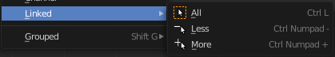
Linked

All
Select all strips that are adjacent to the current selected strip.

Less
Decrease the selection of strips that are adjacent to the current selected strip.

More
Increase the selection of strips that are adjacent to the current selected strip.

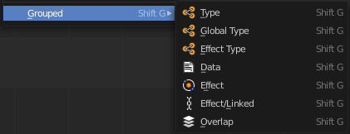
Grouped
Select all strips that are equal to the current selected strip by the chosen method. The menu items should be self explaining.

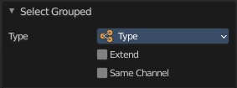
Last operator Select Grouped

Type
The selection method.

Extend
Extend the selection

Same Channel
Select just strips that are in the same channel.

